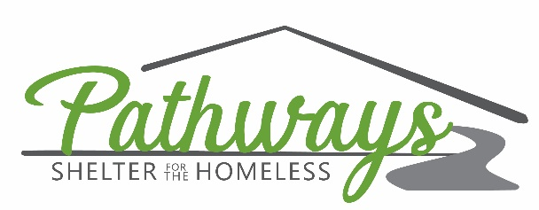

Job Title: Weekday Check-In Advocate
Reports to: Weekday Lead Overnight Advocate
Reviewed: 11/22/2021

Position Summary: The Weekday Check-In Advocate is responsible for assisting with the basement emergency shelter check-in process from Monday through Thursday. This position will perform the bag search and metal detector search during the intake process, and will assist the Weekday Lead Overnight Advocate where needed during each shift.

Requirements: High School Diploma required or GED. Prior experience in a Human Services related field preferred but not required.

Core Values: Pathways has 6 core values (listed below) that will be adhered to by all staff, board members and volunteers.
- Integrity: We act in a way and make decisions that are, at all times, honest, truthful, transparent, authentic, consistent, and relative to Pathways’ mission and values. We will show accountability to see each task through to its fulfillment and hold others to the same expectation. We actively listen and are open to feedback and improvement. We take responsibilities for our mistakes and learn from them. We acknowledge our roles in conflicts and participate in finding and implementing solutions.

- Respect: We value, listen to, learn from and appreciate each other, our clients, our board, our donors and our community. We treat every person with dignity. We assume the best intentions in all people, giving everyone the benefit of the doubt. We give feedback directly, respectfully, and with a focus on solutions. We communicate our needs and expectations openly, and do not get angry at others’ failures to fulfill expectations we do not clearly set. We carry out conversations and actions in a way that is thoughtful and high in quality.

- Inspiration: We choose to see the potential in every person we meet. We inspire hope and create opportunities that empower. We will strive to be passionate about breaking the cycle of homelessness in those we serve. We will be actively present while on duty for Pathways, whether at the facility, in the community, or at a meeting. We will arrive ready to make a difference in the lives of those we serve.

- Excellence: We will demonstrate exceptional performance and service. We will implement programs that not only meet our mission, but also meet our mission beyond expectations. We will evaluate every aspect of pathways, including our board, employees, clients, and specific programs.

- Community: We are community leaders and advocates for individuals and families experiencing homelessness, and those at risk of homelessness. We will engage in various aspects of the Yankton community and surrounding areas. We will seek out partnerships that will be mutually beneficial. We will encourage collaboration between Pathways and other agencies, businesses or organizations and strive to eliminate the duplication of resources.

- Responsible Stewardship: We will receive and accept all gifts or donations with enthusiasm and express sincere thanks using appropriate methods. We will demonstrate responsible use of the gifts and donations and provide proof of responsible use. We will provide recognition for donors in a respectful and appropriate manner.
Essential Duties and Responsibilities include the following. Other duties may be assigned as needed.
Operations
- Understand and maintain strict confidentiality for every Pathways client.
- Be knowledgeable of community agencies and services, provide advocacy towards these resources on behalf of Pathways clients.
- Uphold Pathways’ policies and procedures, strictly enforcing Pathways’ rules.
- Recognize & deal with crisis situations, but knowing own limitations, knowing when to alert authorities or ask for help.
- Maintains a positive team approach to services by ensuring that all concerns or potential conflicts are addressed immediately with the best interest of the client, solidarity of the staff and the mission of Pathways being a focus over self.
- Perform bag searches and metal detector searches during the intake process.
- Assist with providing the evening meal to basement clients.
- Be available for client needs throughout each shift.
- Perform any laundry or cleaning as needed throughout shift.
- Perform any organization of goods throughout shift.
- Any other duties agreed upon by supervisor and employee.
Administrative Tasks
- Monitor security cameras throughout shift.
- Attend meetings and trainings as requested by supervisor.

Hours: Friday through Sunday from 6:30pm to 10:30pm (16 hours per week). Other shifts as determined by employee and supervisor.
Wage: $12/hour
Benefits: No benefits are offered with this position.

Advocate signature: ____________________________ Date: ___________

Executive Director signature: ________________________ Date: ___________

